After reviewing the website in multiple views, I found some things that need to be addressed. The image below shows the view from a Galaxy S5 mobile device. The navigation banner needs to be adequately adjusted to fit this screen size, and the images need to be resized to fit this screen size.

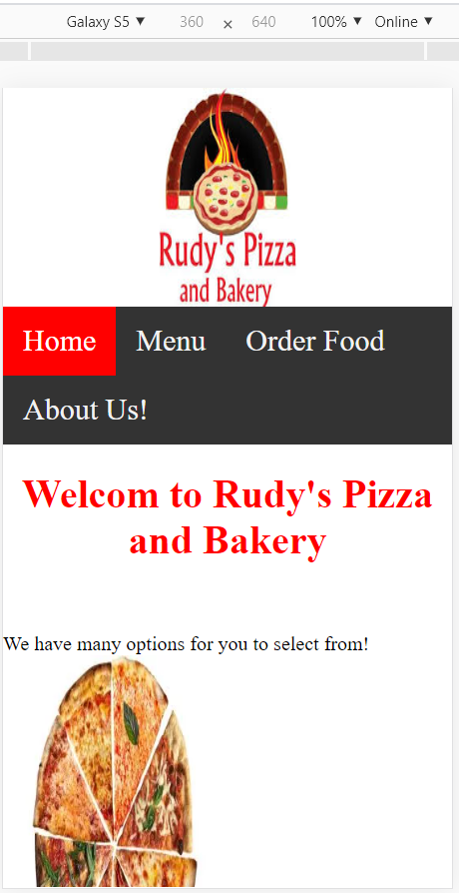

The image below is from a Pixel 2 XL screen view. The same issues need to be addressed the navigation banner needs to be appropriately adjusted to fit this screen size, and the images need to be resized to fit this screen size.

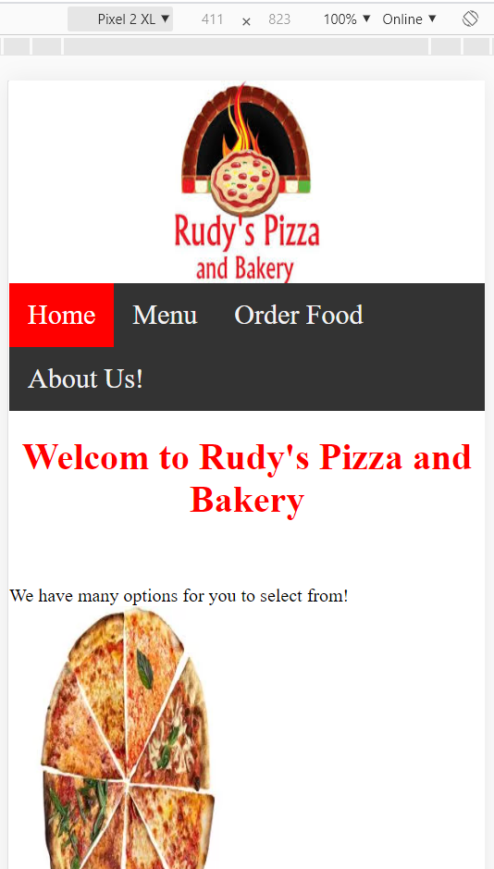

Finally, we have a view from an iPad Pro screen. And this particular view doesn’t have that many issues like the previous ones do. We only need to readjust the image sizes to make it look more responsive looking.

